**CA2 TEMPLATE 1: Storyboarding APPENDIX A**

Use this as a guide to check your narrative flow. You may, of course, shuffle the sequence of your narrative (the Disclaimer frame cannot be shifted) and your parts of narrative are not constrained by the number of boxes. Feel free to adapt this template. Fill the boxes with pictures and use the lines for captions.

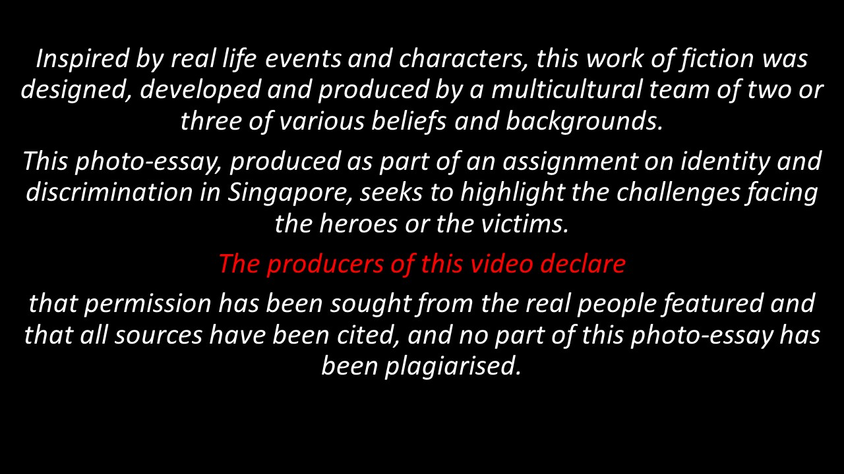Disclaimer

Frame #1

*We hope that through this project, we will be able to…*

*_Captions*______________________________ *__(Will be good to include what______ _ ___ _(In these frames you will develop the* ____________________________________ _____*your intention is)_*_______________ ___ *character and the story)*_____________

Box #25

LIST OF REFERENCES (Harvard Style)

Frame #25

Frame #2

**…**

*__ (PEPS facts or stats that highlight ___ _ causes or consequences can appear __ (It’d also be good to acknowledge______*

_________________________________ ____ *anywhere in your story)*_________ *your interviewees for their insights)_____*

**CA2 TEMPLATE 2: Brainstorming APPENDIX A**

Title of photo-essay: _______________________________________________________________

Your intended message(s): __________________________________________________________

* This narrative is told from the _________________ (hero’s / victim’s) perspective.
* Your photo essay will be told from a **first-person POV**.

**Character Profile:**

|  |
| --- |
| **Name:** |
| **Age:** |
| **Gender:** |
| **Other relevant info (eg: race, nationality, language, job):** |
| **Type of discrimination being fought / faced:** |

Identity describes the way ***individuals and groups define themselves*** and are defined by others on the basis of ***race, ethnicity, religion, language, and culture***“. – Francis M Deng, *War of Visions: Conflict of Identities in the Sudan*

**Causes/consequences of discrimination in your narrative:**

|  |  |
| --- | --- |
| **What cause(s) the discrimination? Why is the group/individual discriminated against?** | |
| Personal  Physical appearance/behaviour? Are the cultural practices of the affected group markedly different? |  |
| Social  Does society value certain things/ideas that the affected group lacks? Do the mass media create and reinforce some negative ideas about the affected group? Have certain highly publicized events created negative views of the affected group? |  |
| Economic  Income level/ social status of the affected group? Access to economic opportunities? |  |
| Political  Do certain government policies/laws disadvantage the affected group? |  |
| **What happens to your protagonist (hero or victim) as a result?** | |
| Personal  Does your protagonist feel hurt, angry, disappointed, scared because of the discrimination? Does this cause your protagonist to view himself/herself in a negative way? |  |
| Social  Do people avoid your protagonist or look at him/her in a negative way? Do people respect your protagonist for what s/he has done?  Does s/he have friends? |  |
| Economic  Has your protagonist’s job opportunities increased or decreased? Has s/he been paid better, or has nothing changed, or has s/he become worse off? |  |
| Political  Does the affected group have the same rights as others? Is the affected group adequately represented in politics?  Are there government policies that disadvantage or assist the affected group? |  |

***To discriminate against someone is to treat someone who is from a different category of people in an unjust manner.***

***

Note that these templates only serve as guides to help you and your partner craft your final creative product.